3.1.a cos(psi(t)) = Re{e^(j*psi(t))}

Psi(t) = 2*pi*mu*tt.*tt + 2*pi*fzero*tt+phi

3.1.b L_sect = 100

T_sect = L_sect/f_Samp

3.1.c: We are trying to sample frequencies that are more than half of the sampling frequency. The reason for the ups and downs could be because the plotspec function is not having small enough sample sizes so the samples it does calculate “fold” over into the inner frequencies?

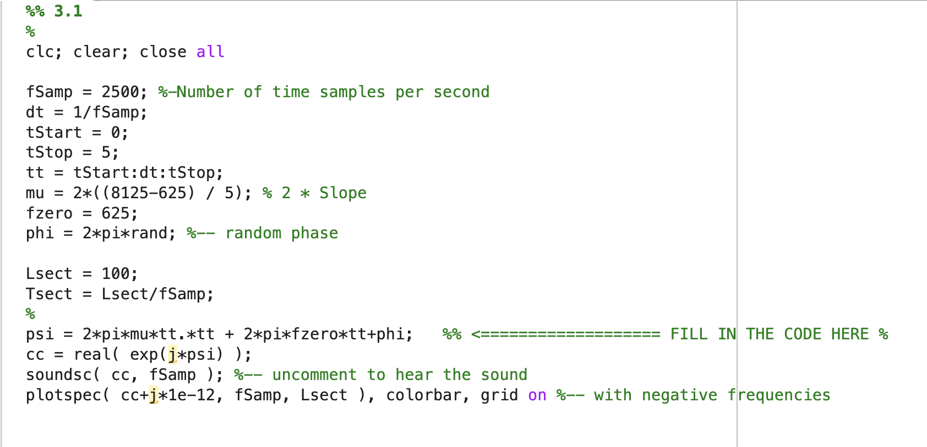

3.2.b

3.2.d

0, 2, 4, 6 harmonics

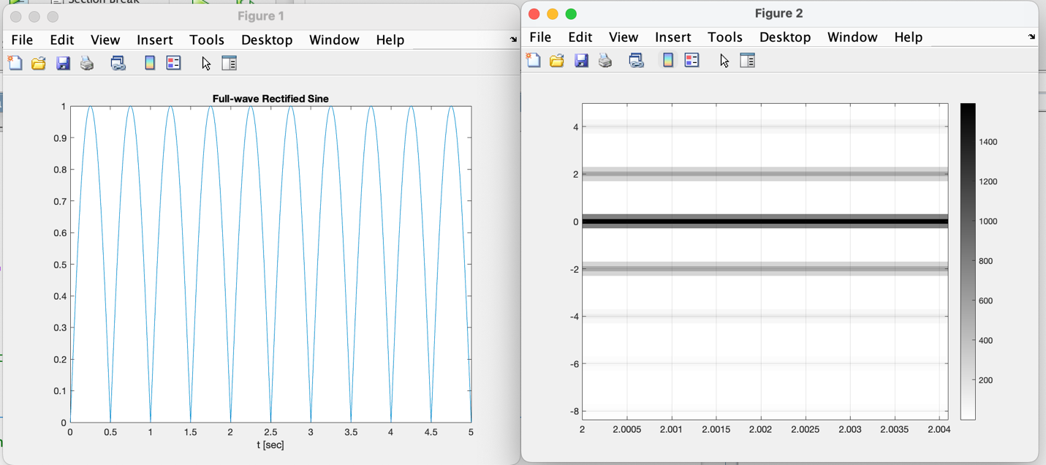

3.2.e

Fundamental Frequency is 1Hz

3.2.f

A_1 = .212 & a_3 = .018

Db difference is -21.3389 dB

3.3.a

If B2 is 6dB bigger than B1, then this implied that it is approximately twice as big since log10(2) is around .3010 and that times 20 is 6.0206 ~ 6dB

3.3b

The db difference between a1 and a3 is -21.3389 meaning a1 is 21.3389 dB bigger than a3 or roughly that a1 is 11.67 times a3

Db spectrum

Frequencies are infinite

Best Value of T_sect is 5

3.5

